Biaxial Strain-Engineered Electronic and Optical Properties of BaTiO₃ for Photocatalytic Water Splitting: A DFT+U Study
S. Tenibar¹, I. Mallek-Zouari^{2,3*}, T. El-Achari⁴, O. Mounkachi^{1,5}.
¹Laboratory of Condensed Matter and Interdisciplinary Sciences (LaMCScI), Faculty of Sciences, Mohammed V University in Rabat, Morocco.
²Université de Tunis El Manar, Faculté des Sciences de Tunis, Laboratoire Matériaux, Organisation et Propriétés (LMOP), Tunis, Tunisie.
³Institut Supérieur des Études Technologiques en Communications de Tunis (El Ghazala), Ariana, Tunisie
⁴Laboratory of Physics of High Energy, Modeling & Simulations (LPHE-MS), Faculty of Sciences, Mohammed V University of Rabat, Av. Ibn Batouta, B. P. 1014 Rabat, Morocco
⁵ College of Computing, Mohammed VI Polytechnic University, Lot 660, Hay Moulay Rachid Ben Guérir, 43150, Morocco
* Corresponding author. Université de Tunis El Manar, Faculté des Sciences de Tunis, Laboratoire Matériaux, Organisation et Propriétés (LMOP), Campus Universitaire El-Manar, 2092 El Manar Tunis, Tunisie.
E-mail address: ikbel.mallek-zouari@fst.utm.tn, https://orcid.org/0000-0003-3253-0041

Abstract
Efficient photocatalysts for solar hydrogen generation must absorb visible light, align with water redox potentials, and enable fast charge transport. Using density functional theory with a Hubbard U correction (DFT+U, U = 5 eV), we study tetragonal BaTiO₃ under biaxial strain (–6% to +6%). Tensile strain reduces the indirect R→Γ band gap from ≈2.46 to ≈2.06 eV, shifting absorption into the visible spectrum. At the same time, the conduction and valence band edges remain well positioned for water splitting, ensuring thermodynamic feasibility. Strain also lowers the hole effective mass, greatly enhancing mobility. Unlike doping or heterojunctions, this approach preserves the intrinsic, defect-free character of BaTiO₃. The combined benefits of visible absorption, robust band-edge alignment, and improved transport identify biaxially strained BaTiO₃ as a clean, efficient, and stable photocatalyst for visible-light-driven hydrogen production.
Keywords: BaTiO₃; biaxial strain; DFT+U; carrier mobility; effective masses; photocatalysis.

1. Introduction
The global energy transition demands sustainable alternatives to fossil fuels. In this context, hydrogen is viewed as a key energy vector, and photocatalytic water splitting offers a renewable route to produce hydrogen from abundant solar energy [1–3]. To serve as an efficient photocatalyst, a semiconductor must meet three essential criteria: (i) a band gap of roughly 2.0–3.0 eV to harvest visible light; (ii) conduction and valence band edges that straddle the redox potentials of H⁺/H₂ and O₂/H₂O; and (iii) high carrier mobilities to suppress electron–hole recombination [4–7]. In practice, many oxide semiconductors fail to satisfy all three conditions simultaneously.
Titanium dioxide (TiO₂) is the most widely studied photocatalyst due to its chemical stability and low cost; however, its wide band gap (~3.2 eV) restricts absorption to the UV region (<5% of the solar spectrum) [8–9]. Strontium titanate (SrTiO₃) exhibits a similar gap (>3.1 eV) and remains active only under UV illumination [10]. Other common oxides, such as ZnO (~3.3 eV) and SnO₂ (~3.6 eV), also absorb only UV light [11–12]. Efforts to extend visible-light absorption through doping or heterojunction formation have had limited success: these approaches often introduce mid-gap trap states that accelerate recombination [13–15].
Perovskite oxides, particularly BaTiO₃, offer a promising alternative. BaTiO₃ is ferroelectric, and its built-in polarization promotes electron–hole separation via internal electric fields [16–17]. In the tetragonal phase, BaTiO₃ inherently straddles the water-splitting redox potentials (with its conduction band minimum below H⁺/H₂ and its valence band maximum above O₂/H₂O) [18]. However, its intrinsic band gap (~3.1 eV) is wide, restricting absorption to UV light. Therefore, finding a way to reduce the band gap without disrupting its favorable band-edge alignment is of great interest.
Strain engineering provides a chemically clean method to tune the optoelectronic properties of materials [19–20]. In practice, biaxial strain can be imposed via epitaxial growth on mismatched substrates or by mechanical clamping. Strain alters the lattice parameters, bond angles, and crystal-field splittings of the material. Previous studies have shown that strain can induce significant changes in ferroelectric polarization and electronic structure in perovskites [21]. In titanate perovskites specifically, biaxial strain has been found to strongly affect band gaps and carrier effective masses [21]. Recent experimental work (e.g. using ball-milling and piezocatalysis of BaTiO₃) further highlights the potential of strain to enhance photocatalytic activity [22].
In this work, we systematically investigate the effects of epitaxial biaxial strain (ranging from –6% to +6%) on the electronic and optical properties of tetragonal BaTiO₃ using DFT+U calculations. We examine the structural relaxation, electronic band structure, band gap evolution, carrier effective masses, mobilities, optical absorption spectrum, and absolute band-edge alignment as functions of strain. By comparing strained BaTiO₃ with benchmark oxides (TiO₂, SrTiO₃, ZnO, SnO₂) and with BiVO₄, we demonstrate why strain-engineered BaTiO₃ is a competitive visible-light photocatalyst. Notably, our results show that tensile biaxial strain can simultaneously achieve a visible-range band gap and improved charge transport while preserving favorable band-edge positions, in contrast to many doping strategies. Despite these advantages, the role of epitaxial strain in tuning BaTiO₃’s photocatalytic performance has not been thoroughly explored to date.

2. Computational details
All calculations were carried out using the Quantum ESPRESSO package within the framework of density functional theory (DFT). The exchange–correlation effects were described using the Perdew–Burke–Ernzerhof (PBE) generalized gradient approximation (GGA), with an on-site Hubbard correction of U = 5 eV applied to the Ti 3d orbitals to account for strong electronic correlations.
Norm-conserving pseudopotentials were employed for Ba, Ti, and O. The plane-wave basis set was truncated at cutoff energies of 60 Ry for the wavefunctions and 480 Ry for the charge density. For structural optimization, variable-cell relaxations were performed using the BFGS algorithm until forces and stresses were minimized. The Brillouin zone was sampled using a 6×6×6 Monkhorst–Pack grid during structural relaxation, while a denser 10×10×10 grid was adopted for self-consistent field (SCF) calculations.
The electronic band structures were calculated along the high-symmetry path Γ–X–M–Γ–Z–R–A–Z in the tetragonal Brillouin zone. The optical properties were derived from the frequency-dependent complex dielectric function, from which the absorption coefficient was obtained.
The effective masses of charge carriers were evaluated by fitting parabolic functions to the band extrema, and the mobilities were estimated within the Drude model approximation. Finally, the absolute band-edge positions relative to vacuum were determined using the Mulliken electronegativity approach [23-26].

3. Results and discussion

3.1 Structural response to strain
We first optimized the crystal structure of tetragonal BaTiO₃, explicitly considering spin polarization, in order to determine its ground-state configuration. The relaxation process preserved the intrinsic P4mm tetragonal symmetry, confirming the stability of this phase under equilibrium conditions. The calculated lattice constants were found to be a = b = 3.98 Å and c = 4.02 Å, in excellent agreement with the reported experimental values (a = b = 3.99 Å, c = 4.02 Å) [27]. Such close consistency between theoretical predictions and experimental data highlights the reliability of the PBE-GGA+U method in accurately reproducing the subtle distortions associated with the ferroelectric tetragonal phase of BaTiO₃. In particular, the slight elongation along the c-axis reflects the off-centering of the Ti⁴⁺ ion relative to the surrounding O²⁻ octahedron, a key structural feature responsible for the spontaneous polarization in BaTiO₃. Therefore, the optimized structure not only validates our computational approach but also establishes a solid foundation for analyzing the strain-induced modifications in its electronic and optical properties, as illustrated in Figure 1-(a).
Table 1 Lattice parameters values of the BaTiO₃ system calculated using PBE-GGA + U approximation

Source | a (Å) | c (Å) | Method
Experimental [27] | 3.99 | 4.02 | XRD
This work | 3.98 | 4.02 | GGA+U
Litterature [28] | 3.96 | 3.99 | GGA

Figure 1-(b) illustrates the effect of in-plane biaxial strain on the out-of-plane lattice parameter (c) and the unit-cell volume (V) of BaTiO₃. Under tensile in-plane strain (ε∥ > 0), the c-axis contracts monotonically while the cell volume increases nearly linearly. Under compressive in-plane strain (ε∥ < 0), c expands slightly and V decreases. This behavior reflects the elastic coupling between the in-plane constraint and out-of-plane relaxation, effectively tuning the tetragonality (c/a) of the crystal. Throughout the explored strain range, c/a remains greater than 1.0, indicating that the ferroelectric polarization along [001] persists under both tensile and compressive strain. This is consistent with prior observations in epitaxially strained ferroelectric perovskites [29].
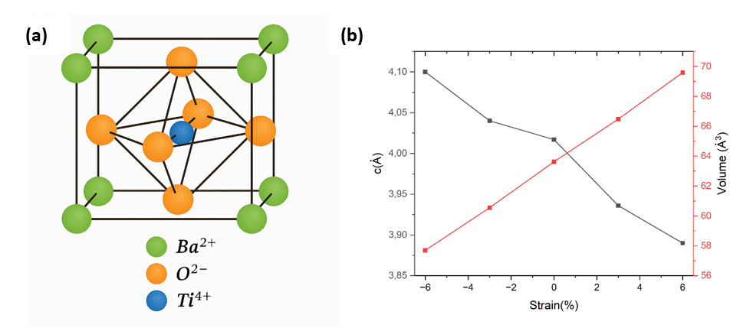
Figure 1. Crystal structure of tetragonal BaTiO₃: (a) schematic representation of the Ba²⁺, Ti⁴⁺, and O²⁻ ions in the perovskite lattice; (b) evolution of the out-of-plane lattice parameter (c) and the unit-cell volume (V) of BaTiO₃ as a function of applied biaxial strain.

3.2 Band structure without strain
At the equilibrium (unstrained) lattice, BaTiO₃ is an indirect-gap semiconductor. Our calculations yield a band gap of approximately 2.46 eV, with the maximum valence band located at the R point and the conduction band minimum at Γ (Figure 2). This R→Γ indirect transition is in agreement with previous DFT studies of titanates [30]. The conduction band is composed mainly of Ti 3d orbitals, and the valence band is mainly O 2p, whereas the Ba states lie much deeper in energy. We note that our calculated gap (2.46 eV) is smaller than the experimental optical gap (~3.1 eV) due to the well-known band-gap underestimation of PBE-GGA+U.
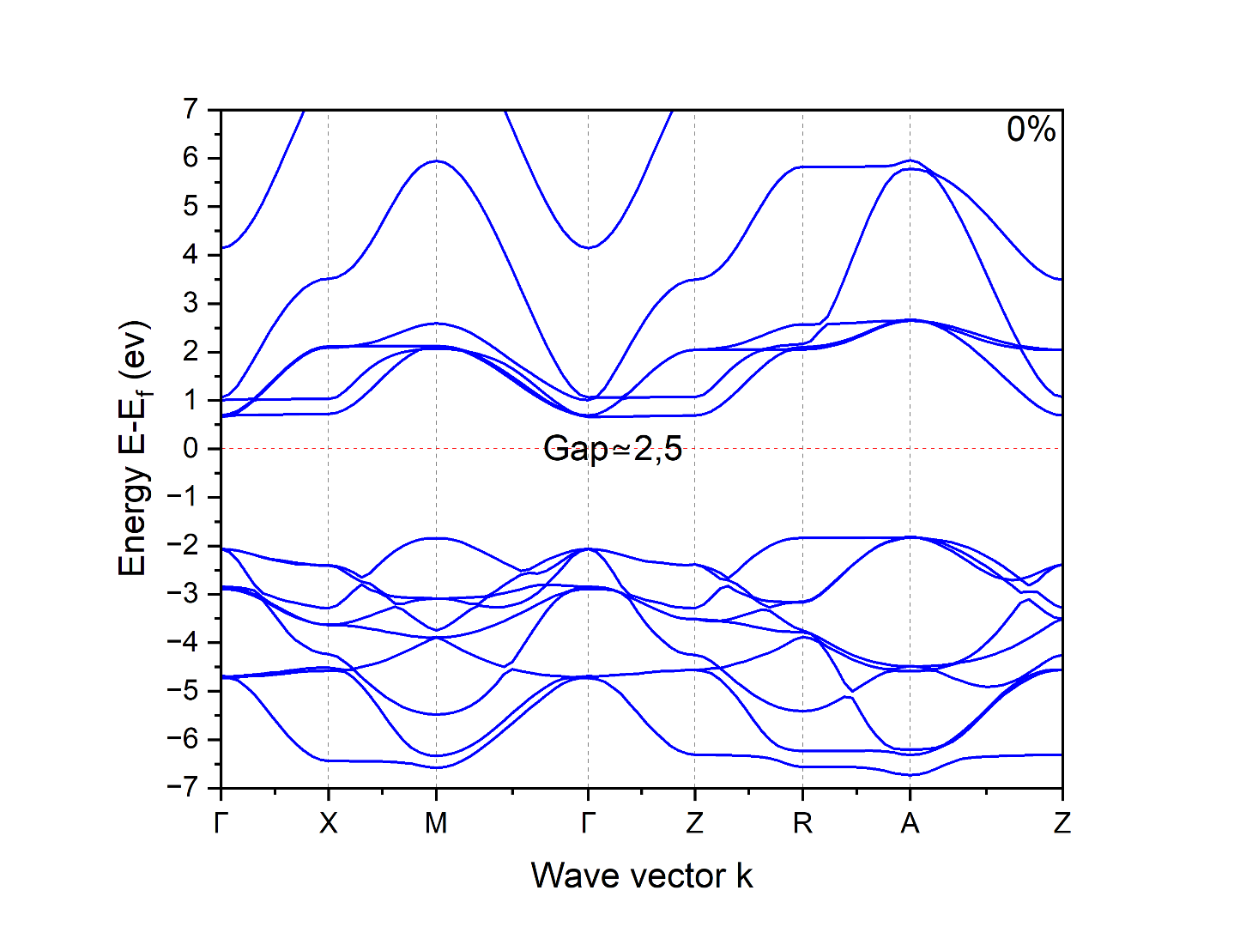
Figure 2. Band structure of BaTiO₃ at 0% strain along Γ–X–M–Γ–Z–R–A–Z, showing an indirect R→Γ band gap.

3.3 Band structures under strain
Figure 3 compares the electronic band structures of BaTiO₃ under representative biaxial strains (–6%, –3%, +3%, +6%). In all cases, the material remains an indirect-gap semiconductor with R→Γ character. Tensile strain has a pronounced effect: it lowers the conduction-band minimum at Γ (by reducing the in-plane Ti–O overlap) and raises the valence-band maximum at R (due to enhanced polarization), resulting in a reduced band gap. For example, at +6% strain the calculated gap is ≈2.06 eV. By contrast, compressive strain has only a minor effect on the gap, keeping it near 2.4 eV. This strain-induced band-gap narrowing under tension is similar to that observed in other oxide perovskites [10] and in mixed oxynitrides [31]. Thus, epitaxial tension effectively tunes BaTiO₃ into the visible-light regime without changing its fundamental indirect-gap nature.
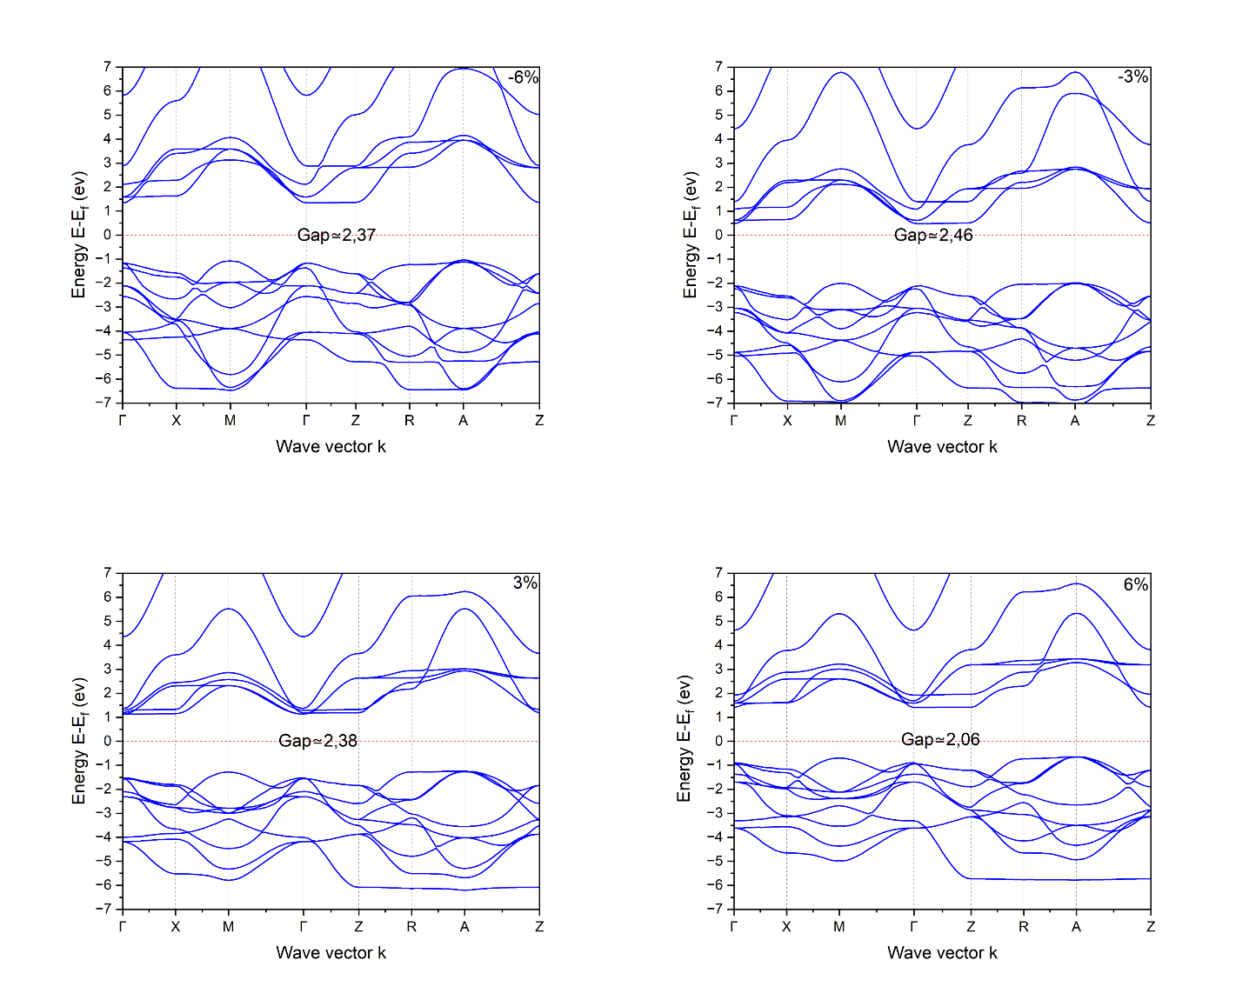
Figure 3. Band structures of BaTiO₃ under biaxial strains (–6%, –3%, +3%, +6%). The indirect R→Γ gap is preserved but shifts under tensile strain.

3.4 Band gap evolution
Figure 4 shows the indirect band gap of BaTiO₃ as a function of biaxial strain. The gap decreases roughly linearly under tensile strain, reaching ≈2.06 eV at +6% (corresponding to an absorption onset near 600 nm). By contrast, the benchmark oxides remain firmly in the UV: TiO₂ (~3.2 eV), SrTiO₃ (~3.2 eV), SnO₂ (~3.6 eV), and ZnO (~3.3 eV) [8,10–12] absorb only ultraviolet light (<400 nm). In other words, strain uniquely allows BaTiO₃ to span the visible spectrum, whereas these materials cannot without extrinsic modification. Notably, BaTiO₃ retains its ferroelectric polarization and favorable band-edge alignment under strain, unlike many wide-gap oxides that require chemical doping or heterostructures to absorb visible light.
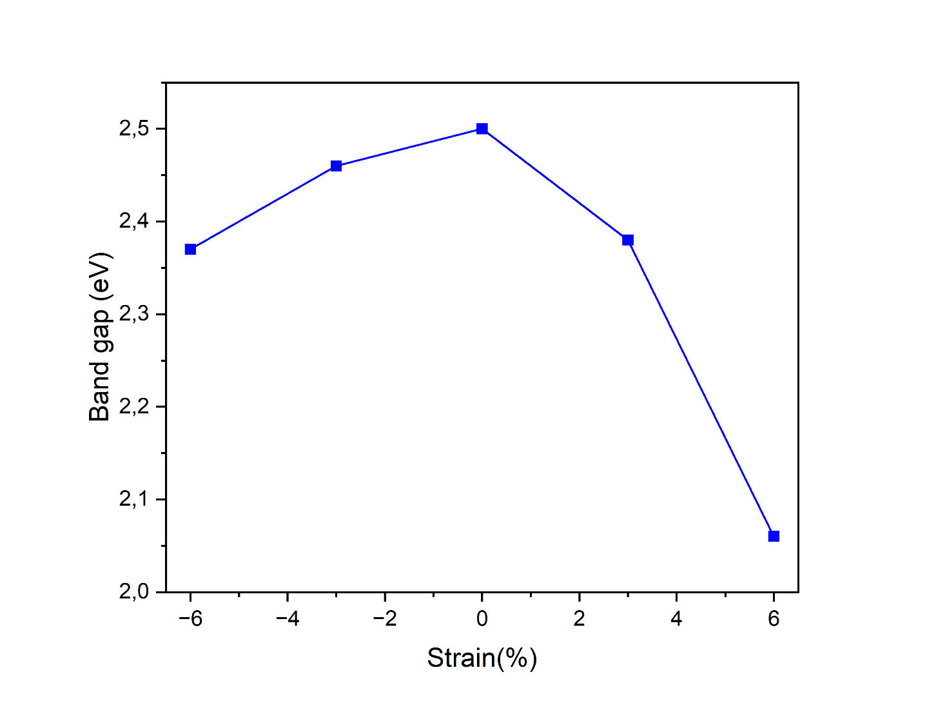
Figure 4. Indirect band gap of BaTiO₃ versus biaxial strain.

3.5 Effective masses and mobilities
Biaxial strain also strongly influences carrier effective masses. As shown in Figure 5, the electron effective mass (at the Γ point) remains light (~0.5 mₑ) and varies only slightly with strain. In contrast, the hole effective mass (at the R point) decreases dramatically under tensile strain: it falls from ~3 mₑ at 0% strain to ~1 mₑ at +6% strain. This implies a substantial increase in hole mobility under tension (Figure 6). For context, TiO₂ is known to have an extremely low hole mobility (<1 cm²/V·s) [32], limiting its oxidation kinetics. Our estimates indicate that BaTiO₃ under +6% strain could achieve hole mobilities >10 cm²/V·s. Such a dramatic mobility enhancement is critical for efficient charge transport, particularly for water oxidation reactions that require holes to reach the surface.
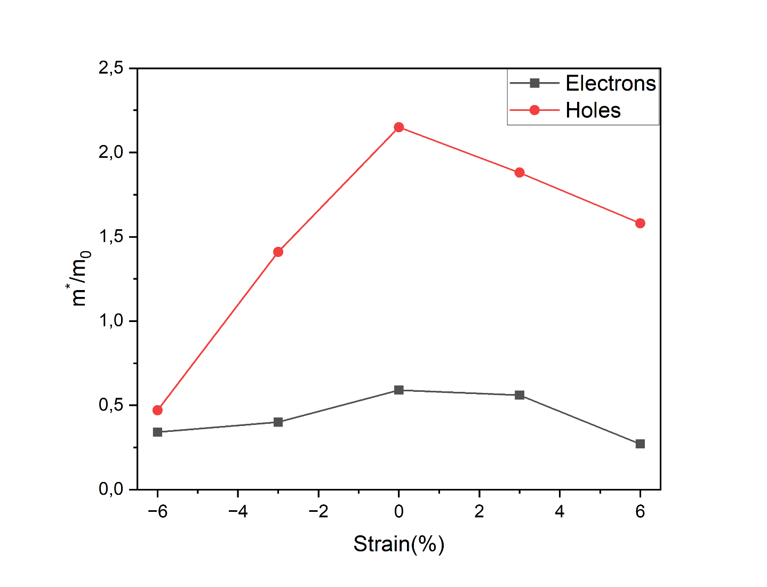
Figure 5. Carrier effective masses (in units of electron mass mₑ) for electrons (black) and holes (red) in BaTiO₃ as a function of biaxial strain.
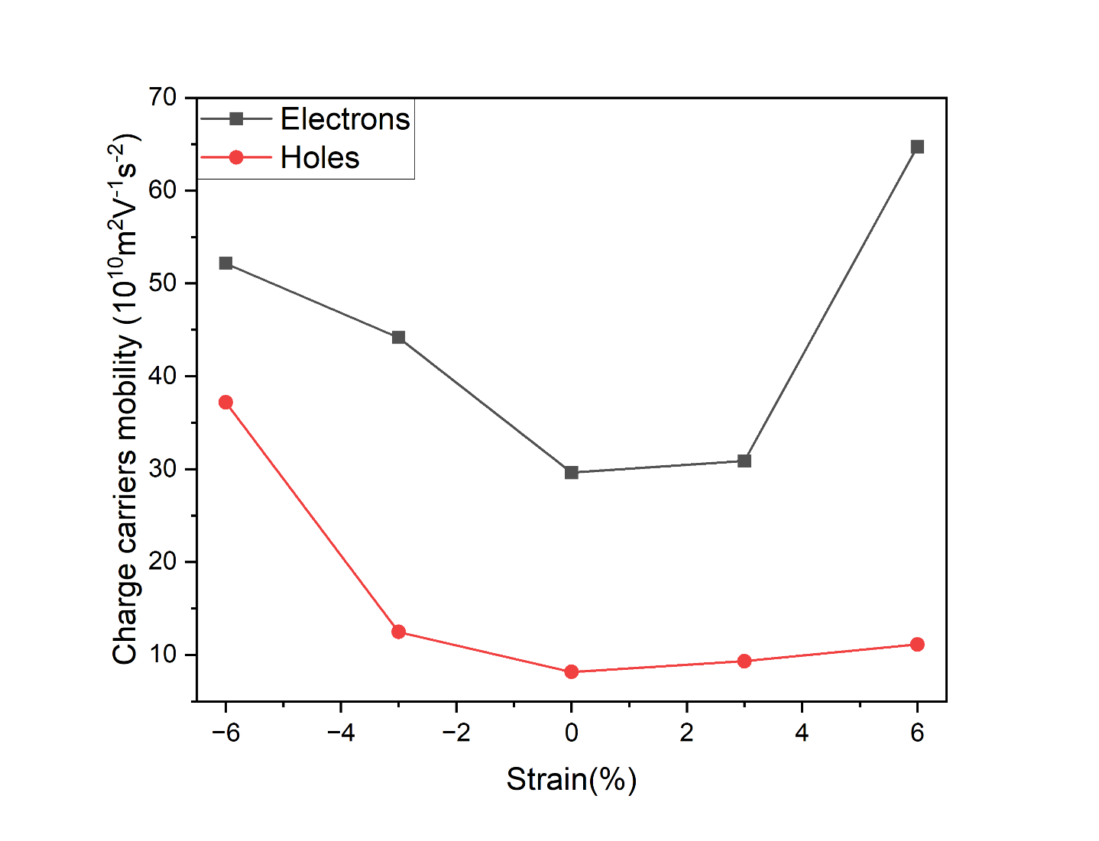
Figure 6. Estimated carrier mobilities in BaTiO₃ versus strain, assuming scattering by optical phonons.

3.6 Optical absorption
Figure 7 presents the calculated optical absorption spectra of BaTiO₃ under different strains. Tensile strain causes a clear redshift of the absorption onset into the visible region, with substantial absorption intensity up to ~600 nm. (Although the gap remains indirect and the onset is relatively weak, the overall integrated visible absorption increases markedly.) For comparison, BiVO₄ (with Eg ~2.4 eV) also absorbs visible light [33], but it’s very low electron/hole mobilities and rapid recombination make it a sluggish photocatalyst. In contrast, strained BaTiO₃ combines a visible-range band gap with high carrier mobilities and ferroelectric-driven charge separation. This synergy addresses two key limitations of BiVO₄—low mobility and fast recombination—in a single material, making strained BaTiO₃ promising for solar water splitting.
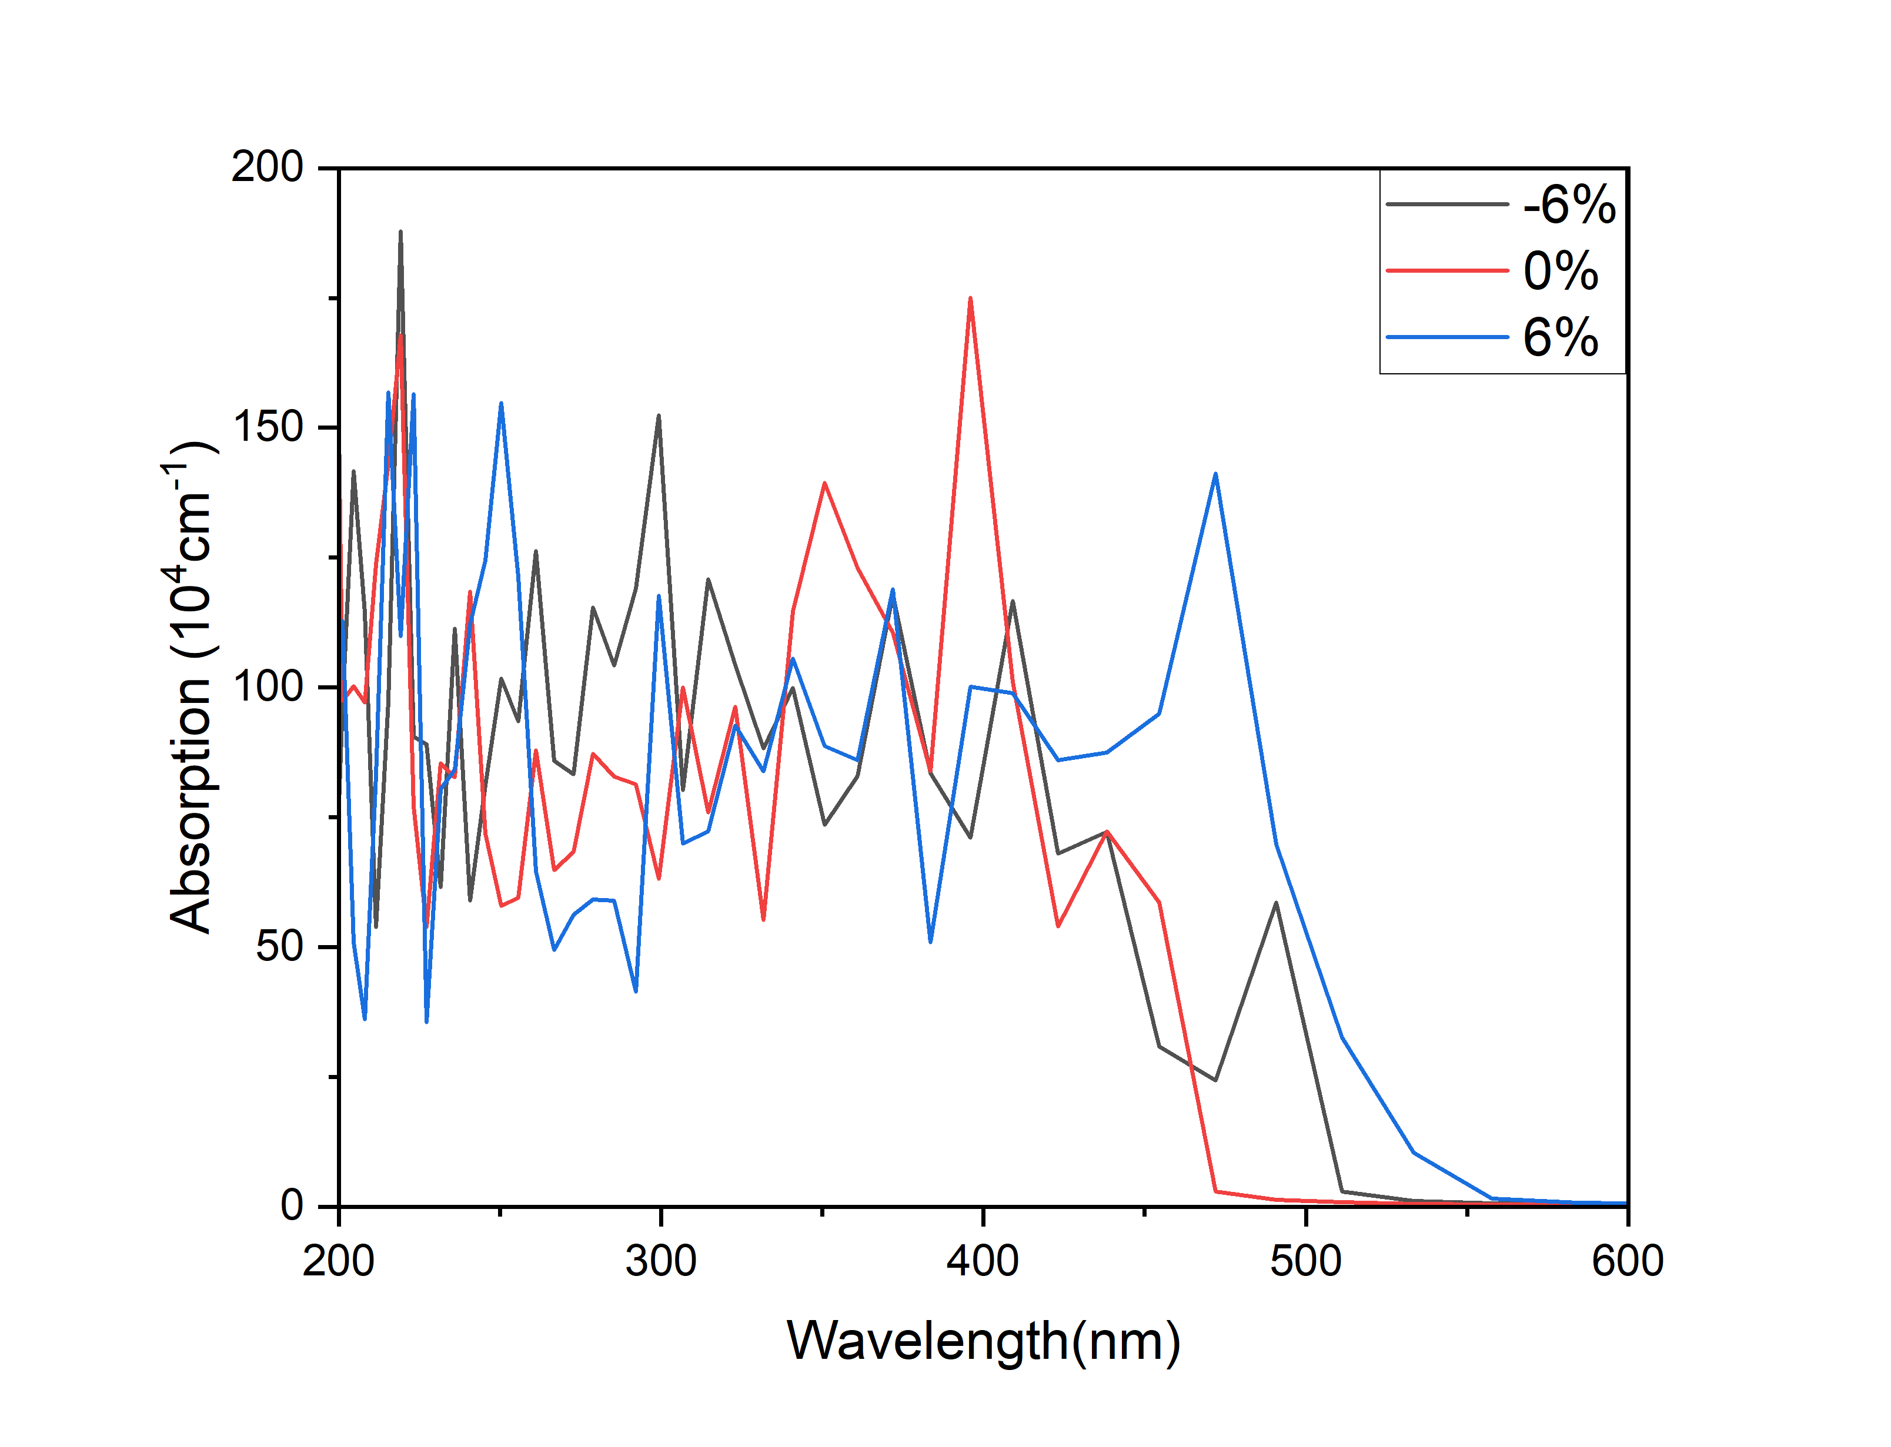
Figure 7. Calculated absorption spectra of BaTiO₃ at –6%, 0%, and +6% strain. Tensile strain shifts onset into the visible.

3.7 Band-edge alignement
Figure 8 shows the estimated band-edge positions of BaTiO₃ (relative to the normal hydrogen electrode) as a function of strain. Crucially, for all strains the conduction band edge remains above the H⁺/H₂ potential, and the valence band edge remains below the O₂/H₂O potential. In other words, BaTiO₃ maintains thermodynamic feasibility for overall water splitting even at +6% strain. Thus, epitaxial strain can tune the band gap without destroying the desired redox alignment. Unlike chemical doping (which often introduces mid-gap states or shifts band edges unfavorably [15]) or alloying (which can create defect traps), strain is a “defect-free” tuning knob: it lowers Eg and improves carrier transport while preserving the intrinsic band-edge positions necessary for water splitting.
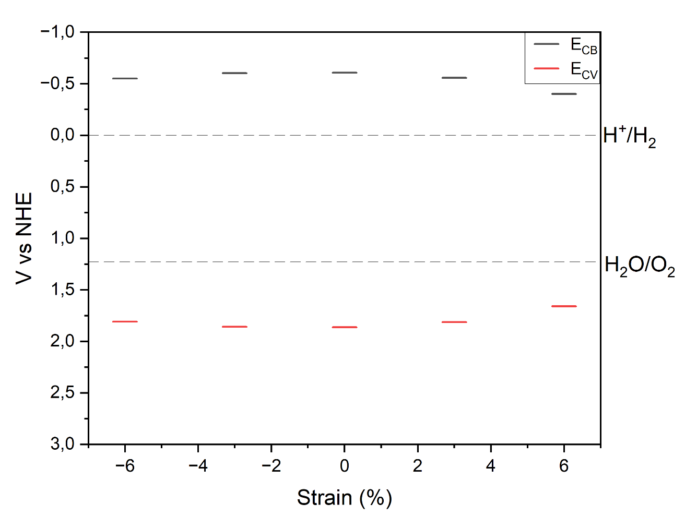
Figure 8. Schematic band-edge positions of BaTiO₃ under different strains, relative to water redox potentials. Strain reduces E₉ but keeps CB above H⁺/H₂ and VB below O₂/H₂O.

3.8 Practical implications
Beyond photocatalysis, our results suggest broader opportunities for strain-engineered ferroelectric oxides. The ability to reversibly tune band gaps and polarizations via mechanical strain could enable adaptive photo detectors, ferroelectric photovoltaics, and varactors that switch their absorption spectra under applied stress. The concept of “strain-bandgap tunability” demonstrated here for BaTiO₃ may extend to other ferroelectric perovskites (e.g. BiFeO₃, SrTiO₃) for multifunctional optoelectronic devices.

4. Conclusion
In summary, epitaxial biaxial strain is shown to be a powerful and clean strategy for optimizing the photocatalytic properties of BaTiO₃. Our DFT+U study demonstrates that moderate tensile strain (up to +6%) reduces the band gap to ~2.06 eV, moving the absorption into the visible-light range while retaining favorable band-edge alignment for water redox reactions. At the same time, strain dramatically enhances hole mobility by reducing the effective mass, overcoming a common bottleneck of oxide photocatalysts. Unlike chemical doping, this approach preserves BaTiO₃’s intrinsic ferroelectric polarization and chemical stability, ensuring both performance and durability. These findings establish strained BaTiO₃ as a robust, defect-free platform for visible-light-driven water splitting and motivate future experimental validation in epitaxial thin films and heterostructures.
CRediT authorship contribution statement
S. Tenibar: Quantum Espresso study, review & editing, I. Mallek-Zouari: Conceptualization, analysis, and writing original draft. T. El-Achari: Provided scientific support, answered theoretical and technical questions, and assisted in interpreting simulation results. O. Mounkachi: discussion of the results and supervision.
Declaration of Competing Interest
The authors declare that they have no known competing financial interests or personal relationships that could have appeared to influence the work reported in this paper.
Acknowledgments
This work was supported by the « Ministère de l’Enseignement Supérieur et de la Recherche Scientifique », Laboratoire LR99ES17 projects.
Data Availability
The datasets used and/or analyzed during the current study are available from the corresponding author upon reasonable request.

Références
[1] C. Acar, I. Dincer, G. F. Naterer, Review of photocatalytic water-splitting methods for sustainable hydrogen production, Int. J. Energy Res. 40 (2016) 1449-1473. https://doi.org/10.1002/er.3549
[2] S.E. Hosseini, M.A. Wahid, Hydrogen from solar energy, a clean energy carrier from a sustainable source of energy, Int. J. Energy Res. 44 (2020) 4110-4131. https://doi.org/10.1002/er.4930
[3] M. Mohsin, T. Ishaq, I.A. Bhatti, A. Jilani, A.A. Melaibari, N.H. Abu-Hamdeh, Semiconductor nanomaterial photocatalysts for water-splitting hydrogen production: the holy grail of converting solar energy to fuel, Nanomaterials 13 (2023) 546. https://doi.org/10.3390/nano13030546
[4] S.B. Rawal, S. Bera, D. Lee, D.J. Jang, W.I. Lee, Design of visible-light photocatalysts by coupling of narrow bandgap semiconductors and TiO₂: effect of their relative energy band positions on the photocatalytic efficiency, Catal. Sci. Technol. 3 (2013) 1822-1830. https://doi.org/10.1039/C3CY00004D
[5] R.B. Marcelino, C.C. Amorim, Towards visible-light photocatalysis for environmental applications: band-gap engineering versus photons absorption—a review, Environ. Sci. Pollut. Res. 26 (2019) 4155-4170. https://doi.org/10.1007/s11356-018-3117-5
[6] P. Zhang, T. Wang, X. Chang, J. Gong, Effective charge carrier utilization in photocatalytic conversions, Acc. Chem. Res. 49 (2016) 911-921. https://doi.org/10.1021/acs.accounts.6b00036
[7] E.A. Abdullah, Band edge positions as a key parameter to a systematic design of heterogeneous photocatalyst, Eur. J. Chem. 10 (2019) 82-94. https://doi.org/10.5155/eurjchem.10.1.82-94.1809
[8] S. Peiris, H.B. de Silva, K.N. Ranasinghe, S.V. Bandara, I.R. Perera, Recent development and future prospects of TiO₂ photocatalysis, J. Chin. Chem. Soc. 68 (2021) 738-769. https://doi.org/10.1002/jccs.202000465
[9] R. Daghrir, P. Drogui, D. Robert, Modified TiO₂ for environmental photocatalytic applications: a review, Ind. Eng. Chem. Res. 52 (2013) 3581-3599. https://doi.org/10.1021/ie303468t
[10] C. Wang, H. Qiu, T. Inoue, Q. Yao, Band gap engineering of SrTiO₃ for water splitting under visible light irradiation, Int. J. Hydrogen Energy 39 (2014) 12507-12514. https://doi.org/10.1016/j.ijhydene.2014.06.059
[11] A.A. Hussain, Q.N. Abdullah, Studying the structural, optical and electrical properties of ZnO:SnO₂ thin films as an application of a gas sensor using vacuum thermal evaporation technique, Tikrit J. Pure Sci. 28 (2023) 66-75. https://doi.org/10.25130/tjps.v28i6.1379
[12] A. Nouri, A. Fakhri, Synthesis, characterization and photocatalytic applications of N-, S-, and C-doped SnO₂ nanoparticles under ultraviolet light illumination, Spectrochim. Acta A Mol. Biomol. Spectrosc. 138 (2015) 563-568. https://doi.org/10.1016/j.saa.2014.11.075
[13] A. Kuddus, S.K. Mostaque, S. Mouri, J. Hossain, Emerging II–VI wide bandgap semiconductor device technologies, Phys. Scr. 99 (2024) 022001. https://doi.org/10.1088/1402-4896/ad1858
[14] B. Abebe, N.K. Gupta, D. Tsegaye, A critical mini-review on doping and heterojunction formation in ZnO-based catalysts, RSC Adv. 14 (2024) 17338-17349. https://doi.org/10.1039/D4RA02568G
[15] Z. Yin, X. Liu, G. Liang, Y. Wang, Unveiling the role of localized polaronic mid-gap states in enhanced carrier transfer in TiO₂/BiVO₄ heterojunctions under visible light irradiation, Sci. Rep. 15 (2025) 24343. https://doi.org/10.1038/s41598-025-10259-9
[16] M. Acosta, N. Novak, V. Rojas, S. Patel, R. Vaish, J. Koruza, J. Rödel, BaTiO₃-based piezoelectrics: fundamentals, current status, and perspectives, Appl. Phys. Rev. 4 (2017) 041305. https://doi.org/10.1063/1.4990046
[17] K. Meng, W. Li, X.G. Tang, Q.X. Liu, Y.P. Jiang, A review of a good binary ferroelectric ceramic: BaTiO₃–BiFeO₃, ACS Appl. Electron. Mater. 4 (2021) 2109-2145. https://doi.org/10.1021/acsaelm.1c00109
[18] Y. Jiang, C.Y. Toe, S.S. Mofarah, C. Cazorla, S.L. Chang, Y. Yin, C.C. Sorrell, Direct hydrogen production from water/seawater by irradiation/vibration-activated using defective ferroelectric BaTiO₃₋ₓ nanoparticles [preprint], arXiv:2206.14961 (2022). https://doi.org/10.48550/arXiv.2206.14961
[19] H. Fei, C. Shang, D. Sang, C. Li, S. Ge, L. Zou, Q. Wang, Application of strain engineering in solar cells, Molecules 29 (2024) 3260. https://doi.org/10.3390/molecules29143260
[20] Y. Miao, Y. Zhao, S. Zhang, R. Shi, T. Zhang, Strain engineering: a boosting strategy for photocatalysis, Adv. Mater. 34 (2022) 2200868. https://doi.org/10.1002/adma.202200868
[21] N. Vonrüti, U. Aschauer, Epitaxial strain dependence of band gaps in perovskite oxynitrides compared to perovskite oxides, Phys. Rev. Mater. 2 (2018) 105401. https://doi.org/10.1103/PhysRevMaterials.2.105401
[22] S. Dahbi, N. Tahiri, O. El Bounagui, H. Ez-Zahraouy, Electronic, optical, and thermoelectric properties of perovskite BaTiO₃ compound under the effect of compressive strain, Chem. Phys. 544 (2021) 111105. https://doi.org/10.1016/j.chemphys.2021.111105
[23] P. Giannozzi, S. Baroni, N. Bonini, M. Calandra, R. Car, C. Cavazzoni, R.M. Wentzcovitch, QUANTUM ESPRESSO: a modular and open-source software project for quantum simulations of materials, J. Phys. Condens. Matter 21 (2009) 395502. https://doi.org/10.1088/0953-8984/21/39/395502
[24] P. Giannozzi, O. Andreussi, T. Brumme, O. Bunau, M.B. Nardelli, M. Calandra, S. Baroni, Advanced capabilities for materials modelling with Quantum ESPRESSO, J. Phys. Condens. Matter 29 (2017) 465901. https://doi.org/10.1088/1361-648X/aa8f79
[25] T. Ahmad, K. Jindal, M. Tomar, P.K. Jha, Theoretical insight of origin of Rashba–Dresselhaus effect in tetragonal and rhombohedral phases of BiFeO₃, Phys. Chem. Chem. Phys. 25 (2023) 5857-5868. https://doi.org/10.1039/D2CP04852C
[26] R.S. Mulliken, A new electroaffinity scale; together with data on valence states and on valence ionization potentials and electron affinities, J. Chem. Phys. 2 (1934) 782-793. https://doi.org/10.1063/1.1749394
[27] C.J. Xiao, C.Q. Jin, X.H. Wang, Crystal structure of dense nanocrystalline BaTiO₃ ceramics, Mater. Chem. Phys. 111 (2008) 209-212. https://doi.org/10.1016/j.matchemphys.2008.01.020
[28] H. Salehi, N. Shahtahmasebi, S.M. Hosseini, Band structure of tetragonal BaTiO₃, Eur. Phys. J. B Condens. Matter Complex Syst. 32 (2003) 177-180. https://doi.org/10.1140/epjb/e2003-00086-6
[29] Z. Kerrami, A. Sibari, O. Mounkachi, A. Benyoussef, M. Benaissa, Improved photo-electrochemical properties of strained SnO₂, Int. J. Hydrogen Energy 43 (2018) 1-5. https://doi.org/10.1016/j.ijhydene.2018.03.199
[30] S. Sanna, C. Thierfelder, S. Wippermann, T.P. Sinha, W.G. Schmidt, Barium titanate ground- and excited-state properties from first-principles calculations, Phys. Rev. B 83 (2011) 054112. https://doi.org/10.1103/PhysRevB.83.054112
[31] W. Wong-Ng, A. Goyal, R. Guo, A.S. Bhalla (Eds.), Synthesis, Properties, and Crystal Chemistry of Perovskite‐Based Materials, Ceramic Transactions Series, vol. 169, The American Ceramic Society, 2006. https://doi.org/10.1002/9781118408476
[32] H. Abnavi, D. Khosh Maram, A. Abnavi, Performance analysis of several electron/hole transport layers in thin film MAPbI₃-based perovskite solar cells: a simulation study, Opt. Mater. 122 (2021) 111258. https://doi.org/10.1016/j.optmat.2021.111258
[33] D. Pradhan, S.K. Biswal, R. Pattanaik, R. Kamal, S.K. Dash, P.K. Panda, N. Nayak, Structural and optical tuning of BiVO₄ via cerium doping for enhanced dye degradation performance, Discov. Appl. Sci. 7 (2025) 907. https://doi.org/10.1007/s42452-025-07476-2

